**VidFlixClub**

Technological Details

Genesis Taylor

Table of Contents

Overview 3

Website Configuration 3

Overview 3

Hostgator Features 3

File Manager 3

Email System 3

Database 4

Wordpress 4

Themes 4

Plugins 5

PHP and HTML Coding 6

PHP script 6

HTML 7

Database and Tables 8

Connection Information 8

Tables and Queries 8

Movie_Picks Table 8

Weeks Table 10

Data Dictionary 11

Movie_picks Table 11

Weeks Table 11

# Overview

The purpose of this document is providing a technical overview to the setup and configuration to the VidFlixClub website. In this document you will read about the technical work that went in to designing this website, which includes both front end and background aspects, and the privileges of both users and administration.

# Website Configuration

## Overview

This website was configured on the [Hostgator.com](http://www.hostgator.com) hosting site using Wordpress. Hostgator is a provider of shared, reseller, virtual private servers, and dedicated web hosting. Wordpress is an online, open source website creation tool written in PHP. Themes and plugins are its main sources to help in the creation of websites. Extra PHP and HTML code was used to design this website.

## Hostgator Features

Hostgator is service dedicated to hosting websites. It comes with a few features that were essential in the design of this project. These features were accessed through the control panel, Cpanel, on their website, [Hostgator.com](http://www.hostgator.com). The ones used to build the VidFlixClub website were the file manager, email system, and database space.

### File Manager

The file manager was used to store all content used to create the website. This includes all mail from the email system, PHP and HTML files, certificates and keys. Files can be uploaded to the hosting space in a number of ways. You can connect by using an FTP account and program or you can upload directly to the system through the file manager in Cpanel.

### Email System

The email system is used to keep admin in contact with the users of the website. There are accounts set up to receive emails from forms that are filled out on the VidFlixClub website. The email system offers admin the option to respond automatically to emails with a prewritten message, filter emails, create mailing lists, and forward messages.

There are two email accounts set up to receive email from the VidFlixClub website. When an email is sent from the VidFlixClub website it is either sent to the main account, [gen@vidflixclub.com](mailto:gen@vidflixclub.com), or the movies account, [movies@vidflixclub.com](mailto:movies@vidflixclub.com). The main account handles general questions and has an auto responder that lets the user know that someone will respond to their inquiry within one business day. The movies account handles emails that pertain to movie suggestions and deletions. Like the main account ,it has an auto responder, letting the user know that we will respond to their request within 24 hours. With this request, the user will be updated with the specifics of their request.

### Database

VidFlixClub stores two databases on the Hostgator hosting space. The first database, ab99783_vidflixclub, was created by the admin to store the movies picked by the group to be watched. Data for this database was created using Excel and MySQL workbench. It was then uploaded to the database through the PHPMyAdmin service on the hosting space. The other database was created when Wordpress was installed on to Hostgator as the creation tool for the website. It contains the data needed to keep Wordpress running smoothly.

## Wordpress

Wordpress 4.2.2 was installed directly from the hosting site in order to help create the website. The path, vidflixclub.com, was selected and all of the necessary files were added. Themes and plugins played an important part in building this website. Wordpress was used to help compensate for the limited HTML and PHP code knowledge. With that came the use of themes and plugins to create the ideal user-friendly website. A copy of the Wordpress files, themes, and plugs are located in the VidFlixClub folder by following the file path: VidFlixClub Final Project > Wordpress.

### Themes

The [Tesseract](tyler.com) theme was used to make the website aesthetically pleasing and user and mobile friendly through a simple responsive design.

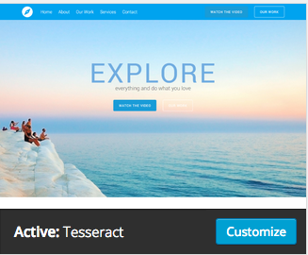

### Plugins

Plugins are used to easily add features and designs to the website. Many of them use shortcode, which is a special Wordpress code that allows you to embed shortcut codes in to page.

#### Askimet

Askimet is a plugin used to protect the website against spam. This plugin automatically checks all comments and filters out the ones that look like spam. It blocks the worst spam to help speed up the site.

#### Black Studio TinyMCE Widget

This plugin adds another visual editor to the edit page that allows you to better create a page or post. This visual editor allows you to switch back to text mode if you would like to manually add HTML code to the page.

#### Contact Form 7

Contact Form 7 is a plugin that allows you to create forms to be entered onto your site. This plugin is used on VidFlixClub.com to create the forms on the Contact Us, Movie Suggestions, and Movie Deletions pages that allow users to email the site administrator. Each form contains a CAPTCHA image that was created using the Really Simple CAPTCHA, which is further explained later in this document.

#### Easy Google Fonts

Easy Google Fonts is a plugin that allows you to combine HTML code with the plugins special code to create fonts for specific needs. This plugin is used on this site to create the fonts on the Home, Contact Us, Movie Suggestions, and Movie Deletions pages and in various buttons.

#### Exec-PHP

This plugin allows PHP code to be manually entered into a page. Wordpress does not automatically allow this to happen. Using this plugin allowed for the created of the Movie Search page to contain the searchable database.

#### Favicon XT-Manager

Favicon XT-Manager allows you to add an icon that browsers display next to a page's title on a browser tab, or in the address bar next to its URL.

#### Google Calendar Events

Google Calendar Events is a plugin that allows you to embed a Google Calendar onto the website. It is used on this website to display a calendar that users can view to see upcoming movies.

#### Page Builder by SiteOrigin

Page Builder by SiteOrigin is a plugin that allows for drag and drop editing within the editing page. It allows you to add various widgets and code to different areas of a webpage.

#### Really Simple CAPTCHA

This plugin allows for the addition of CAPTCHA to forms. It helps to cut down on spam. It is used on this website to cut down on spam that may be emailed to the administrator.

#### SiteOrigin Widgets Bundle

This plugin contains various widgets that were created by SiteOrigin, the same people who created Page Builder by Site Origin. The main widgets used on the site from this plugin are SiteOrigin Image and SiteOrigin Post Carousel. The SiteOrigin Image widget allows images to be displayed easier and the SiteOrigin Post Carousel widget allows posts to be displayed on a page in a scrollable manner.

#### Spacer

This plugin adds a spacer button to the WYSIWYG visual editor, which allows you to add precise custom spacing between lines in your posts and pages.

#### Subscribe to Category

This plugin lets a user subscribe and unsubscribe to posts within a certain category or categories. Subscribers will receive an email with a link to the actual post. Emails to subscribers are sent once every hour. It is used on this site to allow users to be alert when posts are created for new movies. They can subscribe by streaming site as categories.

#### Super Socializer

Super Socializer is a plugin that allows users to login, comment, and share things from your site using social media. Admin sets up applications on each social media platform and uses them with this plugin to allow these connections to happen.

#### Title Remover

This plugin allows you to remove the title from being displayed on pages. It allows for easier design aspects.

## PHP and HTML Coding

### PHP script

PHP script was manually added to the Movie Search page on VidFlixClub.com in order to allow users to be able to search our database for movies. To view that code, please follow the following file path:

* VidFlixClub Final Project > Documents > MovieSearchPagePhpCode.php

### HTML

HTML code was manually entered onto random pages to customize them to fit the look desired. Below are a few examples of the HTML code used on the VidFlixClub website.

#### Movie Search Page

This is HTML from the Movie Search page. To view the file for that code please follow the following file path:

* VidFlixClub Final Project > Documents > MovieSearchPageHTMLCode.html

|  |
| --- |
| <html>  <head>  <meta http-equiv="Content-Type" content="text/html; charset=iso-8859-1">  <title>Vidflix Search</title>  <style type="text/css">  table {  border:1px solid #000000;  border-collapse:collapse;  padding:5px;  }  thead th,  tfoot th {  background-color: #000000; /* Black */  color: #FFFFFF; /* White */  text-align: center;  }  h3 {  font-size: 2.5em; /* 40px/16=2.5em */  font-family: "Trebuchet MS", Arial, Helvetica, sans-serif;  font-style: italic;  color: white;  /*text-shadow: 2px 2px 4px #000000;*/  text-shadow: 1px 1px 2px black, 0 0 25px blue, 0 0 5px darkblue;  }  tr:nth-child(even) { // Even  background: #A4D1FF;  }  tr:nth-child(odd) { // Odd  background: #EAF4FF;  }    </style>  </head>    <body>  <h3>Search by Movie, Genre or Streaming Site</h3>  <form method="post" id="searchform">  <input type="text" name="siteSearch" placeholder="Search by Movie, Genre or Streaming Site ";" />  <input type="submit" name="submit" value="Search"/>  </form>  <br>  </body>  </html> |

#### VidFlixClub Home Page

|  |
| --- |
| <p style="text-align: center;"><span class="headline-resize home-headline">VidFlixClub</span>  <span class="home-sub">Let's talk about it</span>  <a class="button black" href="/amazonprime">Amazon Prime</a> <a class="button black-outline" href="/netflix-movies">Netflix</a></p>  <p style="text-align: center;">[spacer height="300px"]</p> |

|  |
| --- |
| <p style="text-align: center;"></p>  <p style="text-align: center;"><span class="home-descript" style="color: #ffffff;">Weekly Discussions of Member Selected Movies</span></p>  <p style="text-align: center;"></p> |

|  |
| --- |
| <h2>Search by Movies, Streaming Site or Genre</h2>  &nbsp;  <form id="searchform" action="movie-search" method="post"><input name="siteSearch" type="text" placeholder="Search For Movies" /><input name="submit" type="submit" value="Search" />  </form>&nbsp; |

#### Contact Us Page

|  |
| --- |
| <p style="text-align: center;"><span class="headline-resize contact-headline">Contact Us</span></p>  <p style="text-align: center;"><img class="aligncenter wp-image-243" src="http://vidflixclub.com/wp-content/uploads/2015/06/Email-300x236.png" alt="Email" width="280" height="220" />  <span class="contact-sub">For general inquiries, please fill out the form below.  Movie suggestions? Movie deletions? Please click the links below. </span>  <a class="button contact" href="/movie-suggestions">Movie Suggestions</a> <a class="button contact" href="/movie-deletions">Movie Deletions</a></p>  <p style="text-align: center;">[contact-form-7 id="79" title="General Inquiries"]</p> |

Note: a few of the other pages used shortcode. The following is an example of what it may look like: [contact-form-7 id="79" title="General Inquiries"]. This shortcode was created using one of the plugins, Contact Form 7, which was explained earlier in this document.

# Database and Tables

## Connection Information

The current hosting environment and access information to the database:

Host: localhost (database located on Hostgator.com hosting space)

Database: ab99783_vidflixclub

Username: ab99783_genesis

Password: <redacted>

## Tables and Queries

Below are descriptions and basic queries done to create each table. Please check the Movie_picks.sql or Weeks.sql documents in the project folder to view INSERT codes.

### Movie_Picks Table

#### Table Description

## 

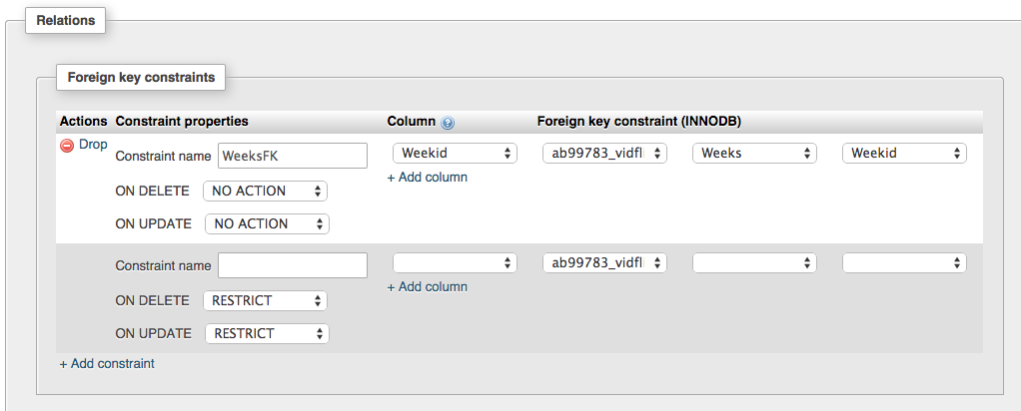

#### Queries

|  |
| --- |
| CREATE TABLE IF NOT EXISTS `Movie_picks` (  `Movieid` int(4) NOT NULL,  `Movie` varchar(200) NOT NULL,  `Weekid` int(4) NOT NULL,  `Genre` varchar(30) NOT NULL,  `Description` varchar(1000) NOT NULL,  `MPRS` varchar(5) NOT NULL,  `Duration` varchar(6) NOT NULL,  `Streaming_Site` varchar(30) NOT NULL,  `Link` varchar(200) NOT NULL  ) ENGINE=InnoDB AUTO_INCREMENT=80 DEFAULT CHARSET=utf8;  ALTER TABLE `Movie_picks`  ADD PRIMARY KEY (`Movieid`), ADD KEY `Weekid` (`Weekid`);  ALTER TABLE `Movie_picks`  MODIFY `Movieid` int(4) NOT NULL AUTO_INCREMENT,AUTO_INCREMENT=80;  ALTER TABLE `Movie_picks`  ADD CONSTRAINT `WeeksFK` FOREIGN KEY (`Weekid`) REFERENCES `Weeks` (`Weekid`) ON DELETE NO ACTION ON UPDATE NO ACTION; |

### Weeks Table

#### Table Description

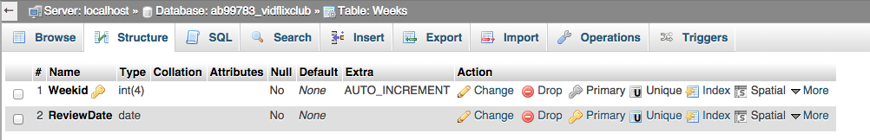

#### Queries

|  |
| --- |
| CREATE TABLE IF NOT EXISTS `Weeks` (  `Weekid` int(4) NOT NULL,  `ReviewDate` date NOT NULL  ) ENGINE=InnoDB AUTO_INCREMENT=47 DEFAULT CHARSET=utf8 COLLATE=utf8_unicode_ci;  ALTER TABLE `Weeks`  ADD PRIMARY KEY (`Weekid`);  --  -- AUTO_INCREMENT for dumped tables  --  --  -- AUTO_INCREMENT for table `Weeks`  --  ALTER TABLE `Weeks`  MODIFY `Weekid` int(4) NOT NULL AUTO_INCREMENT,AUTO_INCREMENT=47; |

## Data Dictionary

|  |  |  |  |  |  |
| --- | --- | --- | --- | --- | --- |
|  | Movie_picks Table | | | | |
| **Column** | | **Type** | **Validation Range** | **Null** | **Description** |
| Movieid (PK) | | Int(4) | (0-9) | No | The unique identification number, primary key for the table, and way of identifying the movie. |
| Movie | | Varchar(200) |  | No | The name of the movie. |
| Weekid(FK) | | Int(4) | (0-9) | No | The id that identifies the week in which the movie from the Movie_picks table would be watched and discussed by the movie club .This is also the foreign key for the table and references the ‘Weeks” table. |
| Genre | | Varchar(30) |  | No | The genre or category that the movie fits in to |
| Description | | Varchar(1000) |  | No | A brief description of the movie. |
| MPRS | | Varchar(5) |  | No | The motion picture rating system rating of the movie. |
| Duration | | Varchar(6) |  | No | The length of the movie. The letter ‘h’ indicates the amount of hours while ‘m’ indicates the amount of minutes. |
| Streaming_Site | | Varchar(30) |  | No | The streaming site in which the movie is located. |
| Link | | Varchar(200) |  | No | A direct link to the movie from the streaming site. |

The Movie_picks table is the main table of the database. It lists all of the information about the movies.

|  |  |  |  |
| --- | --- | --- | --- |
| Weeks Table | | | |
| **Column** | **Type** | **Null** | **Description** |
| Weekid (PK) | Int(4) | No | The id that identifies the week in which the movie from the Movie_picks table would be watched and discussed by the movie club. This is also the foreign key for that table. |
| ReviewDate | date | No | The specific date of which the group will discuss the movie. |